### CS-639 Building User Interfaces, Fall 2019, Professor Mutlu

# Assignments — Week 04 | Design | Structure, Layout, & Navigation

In this two-part assignment, you will first practice the principles of layout design you learned in class in designing the layout of a product page and then use the principles of effective navigation to determine the appropriate navigation model for an e-commerce site, focusing on the check-out process. Part 1 focuses on visual design, building on the principles we have learned in class on visual design as well as layout design. Part 2 focuses on effective navigation that supports the user’s task and not on visual design. For both parts of the assignment, you will primarily use Adobe XD. If you have not yet explored this tool, the first step in completing this assignment would be to visit the Technology Requirements section of the website and follow the instructions to set up and start using Adobe XD. The first part uses assets that are provided in [this template file](https://drive.google.com/a/wisc.edu/file/d/11Zg9USziob138TDjF32F1DgNSybDKmV7/view?usp=sharing).

### Part 1. **Layout Design**

In this part of the assignment, you will be given a set of essential design elements that must be placed on a product page and will be asked to create an effective layout building on one or more of the principles of layout design (e.g., golden proportion, visual hierarchy, visual scan patterns) using these elements. You are not limited to these elements and can add additional elements that help you achieve your layout design goals. Additionally, you can modify the size, typeface, and color of the provided design elements. To complete the assignment, download the Adobe XD template [linked here](https://drive.google.com/a/wisc.edu/file/d/11Zg9USziob138TDjF32F1DgNSybDKmV7/view?usp=sharing), complete your layout design, capture a screenshot of your design, and include it below. Along with your design, provide a brief justification for your layout design choices, specifically why you chose the principle(s) you followed and how did you use the existing and new design elements in support of the principle(s). In your justification, focus on your layout design choices even if you have made additional design choices, such as changing the color of a button or text element.

<design-screenshot>

* See Below

<design-justification>

Design follows the golden proportion where the user focus spirals into the center which is the buy button. Did a high contrast difference between the background image and the background for the text. The text is also blurred out to blend the low contrast together. This makes the white colored font stand out more. The font is changed to provide more unity with the branding and the product through the rounded tips. The button is red to give emphasis and to represent desire for the product.

### Part 2. **Navigation Design**

In this part of the assignment, you will design the navigation structure of an e-commerce website, specifically a store that sells running supplies (e.g., shoes, apparel, accessories). You will focus on the product checkout process, including the pages listed below and additional pages as necessary for the navigation structure you have devised. In your design, you must use one or more of the navigation models we have discussed in class and create the necessary aids for successful navigation. (A good design would likely require combining multiple models.) You will not be judged on the placement or specific design choices of the elements on each page, as we are only focusing on navigation. Place wireframe elements that sufficiently identify the page (e.g., a shopping cart page can look like in [this example](https://xd.adobe.com/view/0c2a796c-5784-4619-4a8c-d54c2c95ecd0-7a1b/?hints=off)). Your pages must have the custom size of 800 x 600 pixels. Add the navigation aids (e.g., links to the home page) that are necessary for your design. Again, do not focus on the design of these aids; our focus is to get the navigation structure right, and we need the bare minimum aids necessary for it. Create a link to your design using the “Share for review” option, and provide the link below. Capture a screenshot of your navigation structure as it appears in the “Prototype” tab in Adobe XD and annotate it to highlight what transitions make up what navigation structure. You can also hand-draw this structure and include a scan/photo below. Finally, justify your navigation model choices in a brief paragraph.

Pages that must be included:

* **Product page** that shows a running shoe and associated information and task options
* **Shopping cart** that lists products that are currently in the cart and options to remove items
* **Options page** that shows shipping address and payment options
* **Confirmation page** that summarizes the purchase and provides options to finalize

When you are determining what additional pages you might need, what navigation model your design might follow, and what navigation aids you might create, think about the user’s task. What are the possible actions that the user might take on each page?

<link-to-design>

<https://xd.adobe.com/view/beb4895a-7005-47c1-4289-719d2efb0208-c885/>

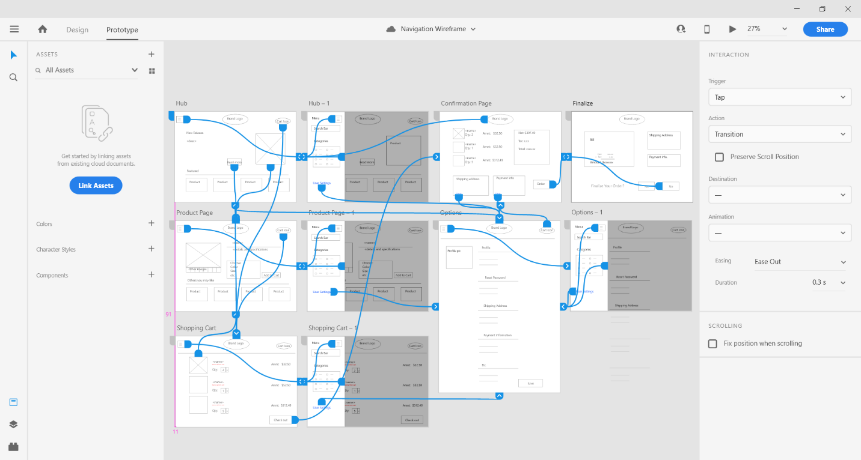<annotated-screenshot>

7.

6.

2.

5.

4.

3.

1.

|  |  |
| --- | --- |
| 1. All pages but the checkout process have a return to hub button to look at new releases and recommendations. 2. Cart Icon on all pages to allow checkout easily. 3. The greyed out screen focuses user on the navigation pane, clicking it would return the user. 4. User would be able to visit the product again by clicking on the image, from hub or from shopping cart. | 1. Have a User Settings link in navigation menu so that user can access their profile information anywhere. 2. Allow the user to make final changes, also serves as a secondary escape hatch other than the brand logo 3. Locks the user in finalize purchase, with only the No button to return to previous screen. |

<design-justification>

I chose a multi-level navigation structure to minimize the cost of navigating the shopping website. If the users are able the get anywhere of the website with ease, they will feel less frustrated and more likely to buy the products. The multi-level focuses on the three main functions critical to consumer purchase: the hub to check out products, the user settings for payment and shipping information, and lastly, the shopping cart to checkout. These 3 main functions are accessible almost anywhere with just 1-2 clicks away. The only screen that isn’t fully connected is the Finalize screen, so that it would lock the user in and funnel their options into purchasing the products.